

Saudi Journal of Medical and Pharmaceutical Sciences
Abbreviated Key Title: Saudi J Med Pharm Sci
ISSN 2413-4929 (Print) | ISSN 2413-4910 (Online)
Scholars Middle East Publishers, Dubai, United Arab Emirates
Journal homepage: https://saudijournals.com

Original Research Article |  | Botany

Impact of Sodium Chloride on Growth, Metabolic Activity, and Antimicrobial Potential of Eurotium Species
O.M.O. El-Maghraby¹, M.S. Youssef¹, Marwa M. Abdel-Kareem¹, Randa A. Fathy¹*

¹Department of Botany and Microbiology, Faculty of Science, University of Sohag, Sohag, Egypt

DOI: https://doi.org/10.36348/sjmps.2026.v12i01.008 | Received: 18.11.2025 | Accepted: 10.01.2026 | Published: 20.01.2026

*Corresponding author: Randa A. Fathy
Department of Botany and Microbiology, Faculty of Science, University of Sohag, Sohag, Egypt

Abstract

In recent years, there has been increasing interest in the study of extremophilic microorganisms, which include halophiles and halotolerants. These microorganisms, able to survive and thrive optimally in a wide range of environmental extremes, are polyextremophiles. In this context, one of the main reasons for studying them is to understand their adaptive mechanisms to stress caused by extreme living conditions. The present study investigated the halotolerance and metabolic responses of five Eurotium species (E. amstelodami, E. chevalieri, E. cristatum, E. montevidense, and E. proliferans) under varying sodium chloride (NaCl) concentrations (0–25%). Fungal growth, medium pH, pigment production (visible light absorbance at 512 nm), fluorescence (254 and 366 nm), organic matter, total nitrogen content, and antimicrobial activity against bacterial (Bacillus subtilis, Escherichia coli) and fungal (Candida tropicalis, Candida albicans) strains were evaluated. All isolates exhibited halotolerant behavior, with maximal growth, organic matter, nitrogen content, fluorescence, and pigment accumulation at moderate salinity (15% NaCl). Antimicrobial activity was strongest at low to moderate NaCl concentrations (0–10%) and absent at ≥15% NaCl, reflecting the inhibitory effect of extreme salinity on secondary metabolite production. The pH of the culture media varied with salinity, generally decreasing under moderate salt stress and increasing at the highest NaCl levels. These patterns indicate that mild osmotic stress promotes both primary and secondary metabolism, whereas severe salinity suppresses growth and bioactive compound synthesis. The study highlights the ecological adaptability of Eurotium species to saline environments and their potential as sources of halotolerant enzymes, pigments, and antimicrobial compounds
Keywords: Eurotium species, halophilic and halotolerant fungi, sodium chloride, fluorescence, organic matter, nitrogen content, saline environments, antimicrobial activity.
Copyright © 2026 The Author(s): This is an open-access article distributed under the terms of the Creative Commons Attribution 4.0 International License (CC BY-NC 4.0) which permits unrestricted use, distribution, and reproduction in any medium for non-commercial use provided the original author and source are credited.

INTRODUCTION
The study of extremophilic microorganisms has gained increasing research interest. Halophilic microorganisms as part of extremophiles, are defined as surviving and multiplying at elevated NaCl levels, and for some, this is an obligatory condition for their development. These microorganisms, which can survive and thrive optimally under a variety of extreme environmental factors, are polyextremophiles (Bowers et al., 2009; Seckbach & Rampelotto, 2015). Their tolerance parameters and salt requirements depend on specific environmental factors such as temperature, pH, and growth medium. Thus, one of the main reasons for their research is to elucidate the adaptive mechanisms to the stress resulting from harsh living conditions. According to Oren (2010), halophiles are defined as microorganisms that grow optimally in NaCl concentrations above 0.2 M. Based on their salt tolerance, they are classified into three groups: weak halophiles (1–3% NaCl), moderate halophiles (3–15% NaCl), and extreme halophiles (15–30% NaCl). Microorganisms adapted to saline habitats that can grow and develop in both the presence and absence of salt are called halotolerants (Dutta & Bandopadhyay, 2022).

The common characteristics of halophilic microorganisms include low nutrient requirements, resistance to high salt concentrations, and the ability to balance the osmotic pressure of the environment (Ventosa et al., 1998). Halophilic microscopic fungi, as eukaryotes, attract research interest. In a saline environment, halophilic fungi are mainly subjected to two different types of stress—osmotic and ionic (Gunde-Cimerman & Zalar, 2014). Hyperosmotic stress is characterized by a decrease in turgor pressure and dehydration of the cytoplasm, which leads to an increase in the concentration of solutes in the cytosol. Ionic stress is associated with the entry of ions into the cytoplasm due mainly to K⁺ ions. The increased concentration of Na⁺ ions inside the cells has a toxic effect on some cellular components, such as intracellular membranes and enzymes, and they are not part of the adaptation mechanisms (Plemenitaš et al., 2016; Gunde-Cimerman et al., 2018).

A feature of salt-adapted microorganisms is their ability to maintain a balance between the high osmotic pressure of the environment and the low water activity (a_{w}) outside the cell, as opposed to that inside the cell (for prokaryotes) or intercellular (for eukaryotes) (Le Borgne et al., 2008). In order to maintain the sodium balance in the cytoplasm and counteract the osmotic pressure of the external environment caused by high salinity, their haloadaptive mechanisms include the intracellular storage of KCl above 37% (5 M) or the accumulation of compatible solutes (Bremer & Krämer, 2019). Salt-adapted fungi possess the necessary mechanisms to balance cellular osmotic pressure and ion concentration, to stabilize cell membranes and to neutralize intracellular oxidative stress. They usually grow slowly as large amounts of energy are directed to the cellular mechanisms required for survival in adverse conditions. Their survival at high salinity is the result of adaptive mechanisms at the cellular genetic, enzymatic and metabolic levels (Yovchevska et al., 2025a).

Published reports on halophiles in scientific literature refer mainly to bacteria, while information on filamentous fungi is relatively scarce. One of the main reasons for studying halophilic fungi is their remarkable tolerance characteristics as well as ecological and morphological adaptability, which are crucial in efforts to understand the limits of life on Earth and in the Universe. Elucidating the mechanisms of adaptation to halotolerance of halophilic and halotolerant filamentous fungi would contribute to obtaining new knowledge necessary for the development of exobiology, which studies the origin, evolution, and spread of life in the Universe (Onofri et al., 2015; Pacelli et al., 2019). Considering the different survival mechanisms of halophilic fungi and their ability to synthesize metabolites with unique properties, any studies on them would enrich the available scientific information on the problem (Yovchevska et al., 2025b).

Among filamentous fungi, the genus Eurotium contains several species that all grow exceptionally well at low water activities. They are therefore common in foods and feeds preserved with high concentrations of NaCl or sugar (Pitt & Hocking, 2009). The genus Eurotium is also an important mycotoxin-producer (Samson, 2002). Nevertheless, there are no systematic studies on its species biodiversity in natural niches with low water activity. So far, it has been reported that different Eurotium spp. Have been occasionally isolated from moderately saline soils and waters (Abdel-Hafez et al., 1978 & 1989; Grishkan et al., 2003), with some species detected up to ~25–30 % NaCl (a_{w} ≈ 0.85) and representing an indigenous fungal community of these extreme environments (Butinar et al., 2005) and recently E. amstelodami, E. herbariorum and E. rubrum were isolated from the Dead Sea (Kis-Papo, 2001).‏

Osmotic/ionic stress and fungal adaptation
When confronted with elevated salt (e.g., NaCl) concentrations, microorganisms face dual challenges: (1) osmotic stress, which draws water out of cells and reduces turgor; and (2) ionic stress, especially from Na⁺/Cl⁻, which can interfere with enzyme function, membrane potential, and protein folding. In fungi, adaptation mechanisms to high salinity and low water-activity include accumulation of compatible solutes (e.g., polyols like glycerol, mannitol, arabitol; sugars like trehalose), adjustment of membrane lipid composition, ion-transporter regulation, and production of extracellular polymeric substances (EPS) or protective layers. Though much of this has been explored in halotolerant yeasts and black-yeast fungi (Gostinčar & Gunde-Cimerman, 2024), filamentous fungi such as Eurotium appear to adopt similar strategies but remain less well characterized.

Halophilic fungi and their adaptation mechanisms to high salt concentrations
The survival of halophilic fungi at high salinities is facilitated by a range of adaptation mechanisms at various levels: cellular (e.g., increased cell wall thickness and specialized transporter systems), genetic (e.g., transport-related genes and high acidic amino acid content), enzymatic, and metabolic pathways (e.g., oxidoreductase, superoxide dismutase, and the high osmolarity glycerol signaling pathway) (Figure 1).

The membrane structure of halophilic microorganisms plays an important role in adapting to saline conditions. It protects the cell from the harmful effects of elevated salt concentrations and maintains osmotic homeostasis in the cell through appropriate membrane fluidity (Nout et al., 1995). The cell wall and cell membrane of fungal cells are the first to be exposed to the increased salinity of the environment. Fungi include structural changes to the cell wall and cell membrane as well as the presence of pigments and/or hydrophobins in response to increased salinity (Ayangbenro & Babalola, 2017; Hmad & Gargouri, 2024). Structural changes in response to increased salt in the medium include thickening of the cell wall and a change in lipid composition (Su, 2014). The presence of pigments (melanins and carotenoids) that protect halophilic fungi from UV rays and the harmful effects of sunlight is another example of its adaptation (Parray et al., 2021).

‏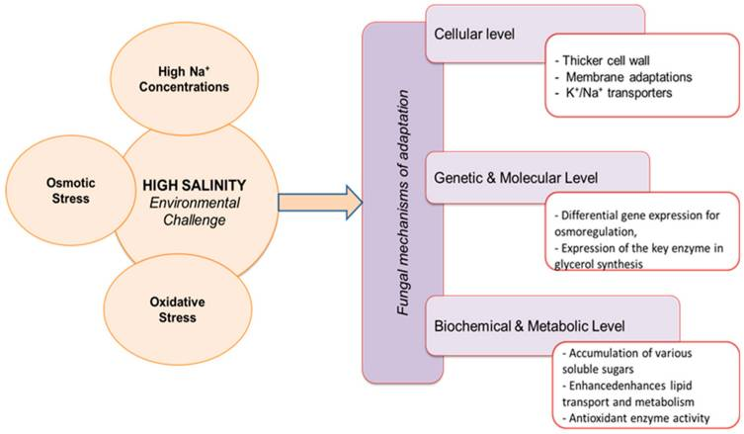
Fig. 1: Fungal mechanisms of adaptations to high salinity

Secondary metabolism and stress-induced biosynthesis
Beyond mere survival and growth, stress conditions (including osmotic and ionic stress) often trigger secondary-metabolite production in fungi. This is because stress can redirect carbon flux from growth to defence or adaptation pathways, altering pigment production, fluorescence signals, enzyme systems, and bioactive compounds (e.g., antimicrobial metabolites, halogenated derivatives). In halotolerant fungi, moderate salinity often stimulates secondary metabolite synthesis, while very high salinity leads to suppression due to metabolic overload or cell-damage (Gunde-Cimerman et al., 2009). Thus, examining growth, pigment/fluorescence, organic/nitrogen content, and antimicrobial activity in response to NaCl provides insight into both adaptation and metabolic potential.

Despite the documented presence of Eurotium spp. in saline habitats, quantitative studies correlating salt concentration gradients with multiple physiological and metabolic endpoints are relatively scarce. This study fills that gap by examining five Eurotium species under varying NaCl concentrations (0–25% NaCl) and assessing a suite of growth and metabolic parameters. Our objectives were: 1. To determine the effect of increasing NaCl concentration on biomass and culture medium pH. 2. To evaluate pigment/fluorescence responses of fungal extracts as indicators of secondary metabolite production. 3. To measure organic-matter and total-nitrogen content in fungal biomass under different salinities. 4. To assess antimicrobial (bacterial and fungal) activity of the extracts as functional readouts of bioactive metabolite deployment. 5. To interpret the observed responses in the context of halotolerance/halophily mechanisms and potential biotechnological applications of salt-adapted fungi. By integrating these endpoints, we aim to elucidate both the physiological adaptation of Eurotium spp. to saline stress and their capacity for producing salt-tolerant metabolites of biotechnological interest.
MATERIALS AND METHODS
Eurotium spp. source and morphological identification:
The five species of Eurotium herbariorum group (halotolerant and/or halophilic fungi) were isolated on 5% NaCl Czapek's agar from desert soils (El-Maghraby et al., 2022) and the soils of the Red Sea Shore, Egypt (El-Maghraby et al., 2025). The isolates were identified based on morphological characteristics (Raper & Fennell, 1965; Lacap et al., 2003) on 10% sucrose Czapek's agar at 28±1°C.

The identity of the five fungal isolates was confirmed by ITS rDNA sequencing, and the sequences were deposited in GenBank under accession numbers: Eurotium amstelodami AUMC16391 (PX589428), E. chevalieri AUMC16390 (PX498623), E. cristatum AUMC16393 (PX589490), E. montevidense AUMC16392 (PX589469), and E. proliferans AUMC16394 (PX589497).

Halophilic ability test using different sodium chloride (NaCl) concentrations
The five species of Eurotium herbariorum group (E. amstelodami, E. chevalieri, E. cristatum, E. montevidense and E. proliferans) were grown in a culture medium with different concentrations of sodium chloride (NaCl) (NaCl: 0%- 2.5%- 5%- 10%- 15%- 20% &25%, sucrose: 50 g/L, KNO₃: 3 g/L, KH₂PO₄: 1 g/L, MgSO₄: 0.5 g/L, KCl: 0.5 g/L & FeSO₄: traces) under constant conditions. After the incubation period, the fungal culture was filtered (Whatman No.1), broth medium and biomass were employed for further analysis

Determination of dry weight (g/L) of Eurotium species
After the incubation period, the fungal biomass was filtered and dried in an oven at 85°C for 24h, and then the fungal growth was measured.

Determination of Organic Matter Content (O.M. %)
Organic carbon was determined by the wet digestion method (Walkley and Black, 1934) through oxidation of the carbon present in the dry weight of the Eurotium species using acid dichromate reagent.

Determination of pH Value:
A pH meter (EUTECH Instruments pH 510 pH/mV/°C meter) was used to determine the pH value of the fungal filtrate.

Determination of Visible Light and Fluorescence
Broth medium of the 5 species of Eurotium spp. were submitted for analyses under visible (512 nm) and ultraviolet (254 nm and 366 nm, short and long waves) light by spectrophotometric analyses.

Determination of Total nitrogen (Kjeldahl method)
Total nitrogen was measured by digesting, distilling, and titrating organic nitrogen present in the dry weight of the Eurotium species using the Kjeldahl method (Kirk, 1950), by conversion of organic nitrogen into ammonium sulfate by digestion with concentrated sulfuric acid (H₂SO₄). The released ammonia (NH₃) is then distilled and titrated, allowing the amount of nitrogen to be quantified.

Pre-Germination of Pathogenic Micro-Organisms (Bacteria and Fungi).
Bacterial isolates (Bacillus subtilis, Gram +ve and Escherichia coli, Gram –ve) were pre-germinated in slants of nutrient agar (peptone, 5 g/l, beef extract, 3 g/l, sodium chloride, 8 g/l and agar, 15 g/l), pH 7.3+/-0.2, dispersed in 1 liter of dist. H₂O, allow to soak for 10 minutes to mix well, then sterilize by autoclaving for 15 minutes at 121°C. Whereas, pathogenic fungi (Candida tropicalis AUMC 9158 & Candida albicans AUMC 9138) were pre-germinated on Sabouraud’s agar (dextrose, 40 g/l, peptone, 10 g/l and agar,15 g/l), pH 5.6+/-0.2, at 37°C for 24 and 48h, respectively, to have a mass of hyphae and/or conidia. At the end of incubation periods, 5 ml of sterilized distilled H₂O was poured on the surface of micro-organism growth, gently crushed by a loop, and transferred to an Erlenmeyer flask (50 ml) containing 20 ml of sterilized dist. H₂O, shaken by hand and directly used for inoculation the media in a Petri dish.

Determination of Anti-bacteria and Anti-Fungi Test.
The agar disc diffusing method was used, where thick layers (~5 mm) of appreciated media (nutrient’s and Sabouraud’s agar) for bacterial and fungal growth were done in Petri dishes (9 cm²). The media were separately inoculated with the desirable organism (1 ml) and dispersed on the surface of the solidified medium using a loop. Standardized discs of filter paper (0.5 cm²) were separately saturated with the filtered broth medium, dried and fixed onto the tested media of bacteria and fungi. The dishes were incubated at the optimum temperature for the growth of the organism as previously described. At the end of incubation periods, the average of two diameters was measured (the diameter of the inhibition zone) and represented the activity of filtered broth media.

RESULTS
1. Growth of fungal isolates under different sodium chloride concentrations (Dry weight)
The growth response of five Eurotium species to different sodium chloride concentrations is provided in Table 1. Isolates were capable of growth in media with up to 20% sodium chloride, with no growth observed at a concentration of 25% sodium chloride. Moderate levels of salinity typically encouraged fungal growth in comparison to the control, whereas both very low and very high salt concentrations resulted in a decrease in biomass production. The species E. montevidense displayed the greatest level of tolerance to salinity, achieving a maximum dry weight of 1.270 g/l at a 15% NaCl concentration, with E. cristatum (1.250 g/l) and E. proliferans (1.177 g/l) also showing high levels of tolerance. The growth of E. amstelodami and E. chevalieri also increased with salinity levels rising up to 15%, reaching concentrations of 1.126 g/l and 0.942 g/l, respectively. In contrast, the lowest biomass values were recorded at 2.5% NaCl for all isolates generally.

These findings indicate that Eurotium species can tolerate and even thrive under moderately saline conditions, with optimal growth typically observed between 10–15% NaCl. However, further increases in salt concentration (20–25%) resulted in a sharp decline or complete inhibition of growth, signifying the upper limit of salt tolerance for these xerophilic fungi.

Table 1: Effect of sodium chloride concentration on dry weight (g/l) of Eurotium species
 | Control 0% NaCl | 2.5% | 5% | 10% | 15% | 20% | 25%
E. amstelodami | 0.738 | 0.194 | 0.358 | 0.939 | 1.126 | 0.213 | -
E. chevalieri | 0.445 | 0.290 | 0.409 | 0.809 | 0.942 | 0.219 | -
E. cristatum | 0.812 | 0.464 | 0.685 | 0.979 | 1.250 | 0.276 | -
E. montevidense | 0.766 | 0.263 | 0.434 | 0.908 | 1.270 | 0.391 | -
E. proliferans | 0.815 | 0.274 | 0.527 | 0.947 | 1.177 | 0.198 | -

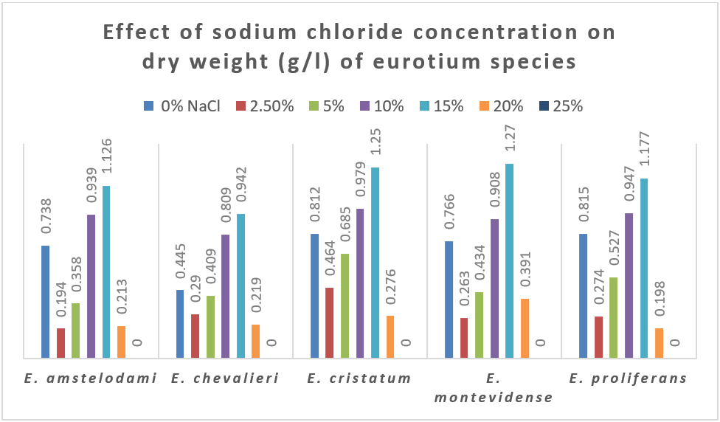
Fig. 2: Effect of sodium chloride concentration on dry weight (g/l) of Eurotium spp

2. Changes in the medium pH value (Effect of Sodium Chloride Concentration on the pH of Culture Media)
The pH values of culture media inoculated with Eurotium species under different NaCl concentrations are presented in Table 2. The initial medium pH was approximately 6.8. The variations in pH were observed depending on both the fungal species and the salt concentration. In general, Eurotium cultures tended to acidify at moderate salinity levels (10–15% NaCl), followed by a marked increase in pH at the highest salt concentration (25% NaCl). The lowest pH values were recorded at 15% NaCl for all species, ranging from 4.41 in E. cristatum to 5.03 in E. proliferans. Conversely, strongly neutral conditions developed at 25% NaCl, where pH values reached 6.72–6.81 across all isolates.

Among the examined species, E. cristatum and E. montevidense showed the most pronounced acidification, while E. proliferans maintained relatively higher pH values at all salt levels. These results suggest that moderate salinity enhances the metabolic activity of Eurotium species, leading to acid production, whereas high salinity (≥20%) may suppress such metabolic processes, resulting in less acid formation or even a shift toward neutralization.

Table 2: Effect of sodium chloride concentration on pH values of culture media inoculated with Eurotium species.
 | Control 0% NaCl | 2.5% | 5% | 10% | 15% | 20% | 25%
E. amstelodami | 4.95 | 5.83 | 5.63 | 5.10 | 4.86 | 5.15 | 6.72
E. chevalieri | 4.96 | 5.48 | 5.37 | 4.80 | 4.56 | 5.60 | 6.81
E. cristatum | 4.58 | 5.76 | 5.50 | 4.54 | 4.41 | 5.56 | 6.74
E. montevidense | 4.58 | 5.66 | 5.67 | 4.61 | 4.43 | 5.35 | 6.73
E. proliferans | 5.39 | 5.80 | 5.70 | 5.24 | 5.03 | 6.00 | 6.80

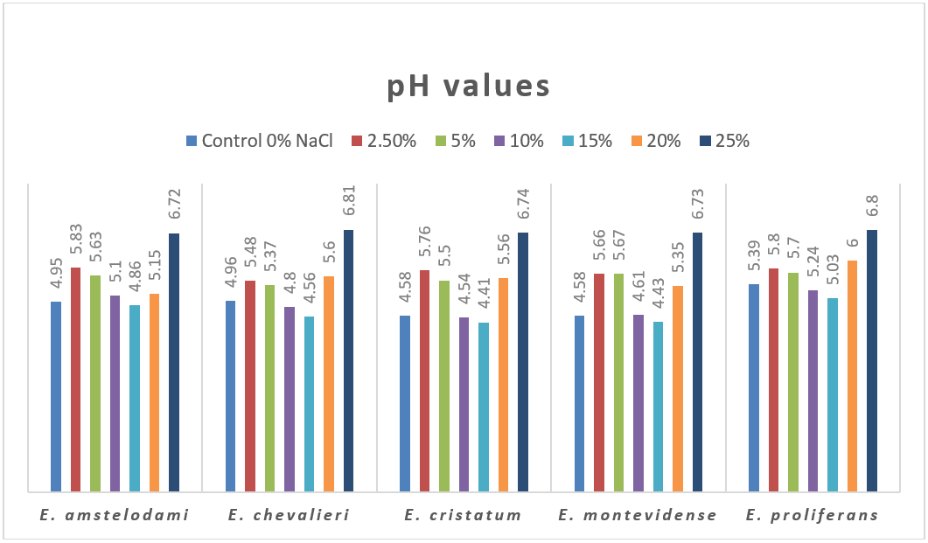
Fig. 3: Effect of sodium chloride concentration on pH values of culture media of Eurotium spp

3. Visible absorbance at 512 nm (Effect of Sodium Chloride Concentration on Visible Light Absorbance (512 nm) of Eurotium Extracts)
The absorbance of Eurotium culture extracts at 512 nm, which reflects the accumulation of colored or chromophoric secondary metabolites, varied notably among the studied species and salt concentrations (Table 3). Moderate NaCl concentrations stimulated pigment production, while very low or high salinity suppressed absorbance values. The highest absorbance values were generally observed at 10–15% NaCl, coinciding with the salt levels that also supported maximum dry biomass. Among the tested fungi, E. montevidense exhibited the most pronounced pigment production, recording a peak absorbance of 0.153 at 15% NaCl, followed by E. proliferans (0.130) and E. cristatum (0.085). All isolates exhibited a significant drop in absorbance at very high salinity levels (25% NaCl), reaching levels of 0.001-0.009. This reduction indicates that severe salinity stress inhibited pigment biosynthesis. Conversely, the relatively higher absorbance observed under moderate salt concentrations suggests that salt stress within a tolerable range enhances secondary metabolite production in Eurotium species.

Table 3: Effect of sodium chloride concentration on visible light absorbance (512 nm) of Eurotium species extracts
 | Control 0% NaCl | 2.5% | 5% | 10% | 15% | 20% | 25%
E. amstelodami | 0.041 | 0.028 | 0.037 | 0.050 | 0.067 | 0.029 | 0.002
E. chevalieri | 0.020 | 0.021 | 0.035 | 0.042 | 0.052 | 0.028 | 0.001
E. cristatum | 0.063 | 0.031 | 0.039 | 0.058 | 0.085 | 0.035 | 0.009
E. montevidense | 0.141 | 0.039 | 0.040 | 0.106 | 0.153 | 0.033 | 0.006
E. proliferans | 0.074 | 0.046 | 0.067 | 0.069 | 0.130 | 0.027 | 0.005

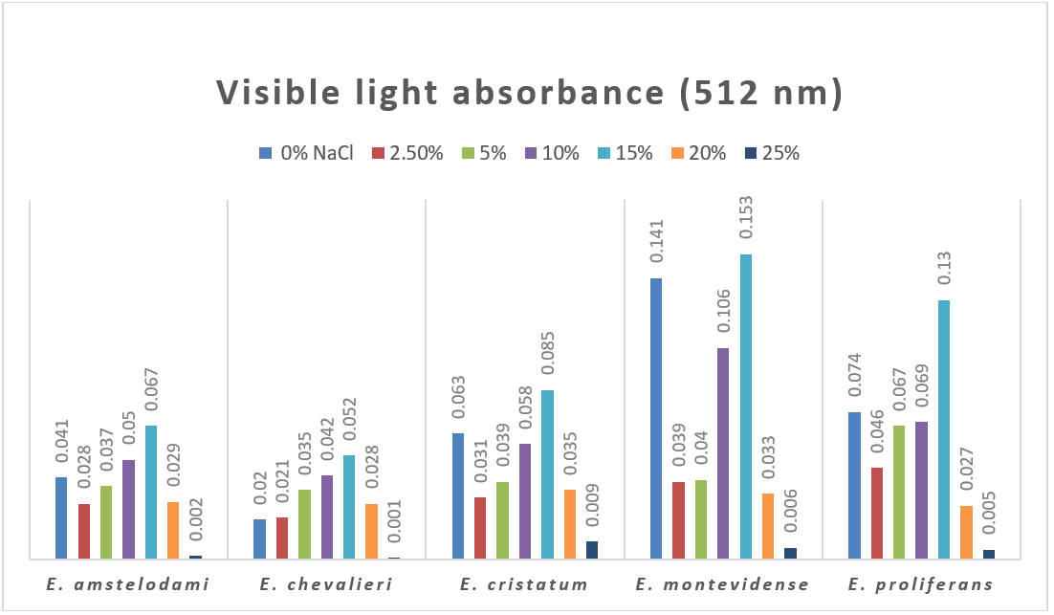
Fig. 4: Effect of sodium chloride concentration on visible light absorbance (512 nm) of Eurotium spp. extracts

4. Fluorescence under UV light (Effect of Sodium Chloride Concentration on Fluorescence Intensity 366 nm and 254 nm of Eurotium Species)
Fluorescence measurements at 366 nm and 254 nm were used to assess qualitative changes in the secondary metabolites produced by Eurotium species under different NaCl concentrations (Table 4). The data revealed marked differences in fluorescence intensity among species and wavelengths, reflecting diverse metabolic responses to salinity stress.

At 366 nm, fluorescence intensities increased significantly with salt concentration up to 15% NaCl, then declined sharply at higher levels (20–25%). The strongest fluorescence was recorded for E. proliferans (1.891) and E. cristatum (1.593) at 15% NaCl, followed by E. montevidense (1.488) and E. chevalieri (1.233). The lowest intensities occurred at 20–25% NaCl, where most species showed values below 0.2, indicating strong inhibition of fluorescent metabolite formation under extreme salinity.

At 254 nm, fluorescence values were generally higher overall (≈2.1–2.5) but showed smaller fluctuations across salt concentrations. The highest readings were observed at 15% NaCl for all species, with E. cristatum and E. proliferans reaching 2.553 and 2.468, respectively. A dramatic reduction in fluorescence occurred at 25% NaCl, where intensities dropped below 0.4 for all isolates.

These results suggest that moderate salinity (particularly 10–15% NaCl) enhances the synthesis of UV-active and fluorescent compounds in Eurotium species, whereas both low and very high salt levels suppress secondary metabolite production. The stronger response at 366 nm compared to 254 nm implies that salt stress may specifically promote the accumulation of chromophoric metabolites such as flavins or aromatic polyketides.

Table 4: Fluorescence intensity of Eurotium species at 366 nm and 254 nm under different sodium chloride concentrations
Eurotium species | 366 nm |  |  |  |  |  |  | 254 nm
Eurotium species | 0% | 2.5% | 5% | 10% | 15% | 20% | 25% | 0% | 2.5% | 5% | 10% | 15% | 20% | 25%
E. amstelodami | 0.581 | 0.272 | 0.306 | 0.562 | 0.746 | 0.175 | 0.070 | 2.296 | 2.105 | 2.255 | 2.334 | 2.347 | 2.074 | 0.270
E. chevalieri | 0.660 | 0.303 | 0.457 | 0.864 | 1.233 | 0.128 | 0.035 | 2.349 | 2.258 | 2.266 | 2.346 | 2.374 | 2.217 | 0.203
E. cristatum | 1.385 | 0.333 | 0.516 | 1.349 | 1.593 | 0.149 | 0.082 | 2.384 | 2.299 | 2.341 | 2.434 | 2.553 | 2.363 | 0.334
E. montevidense | 1.239 | 0.219 | 0.533 | 1.188 | 1.488 | 0.174 | 0.084 | 2.459 | 2.271 | 2.316 | 2.432 | 2.463 | 2.250 | 0.394
E. proliferans | 1.259 | 0.396 | 0.735 | 1.026 | 1.891 | 0.178 | 0.072 | 2.385 | 2.287 | 2.342 | 2.346 | 2.468 | 2.202 | 0.363

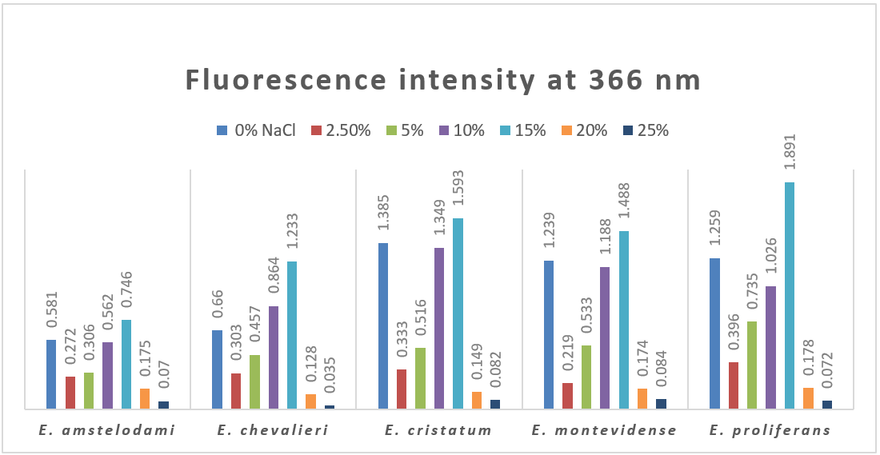
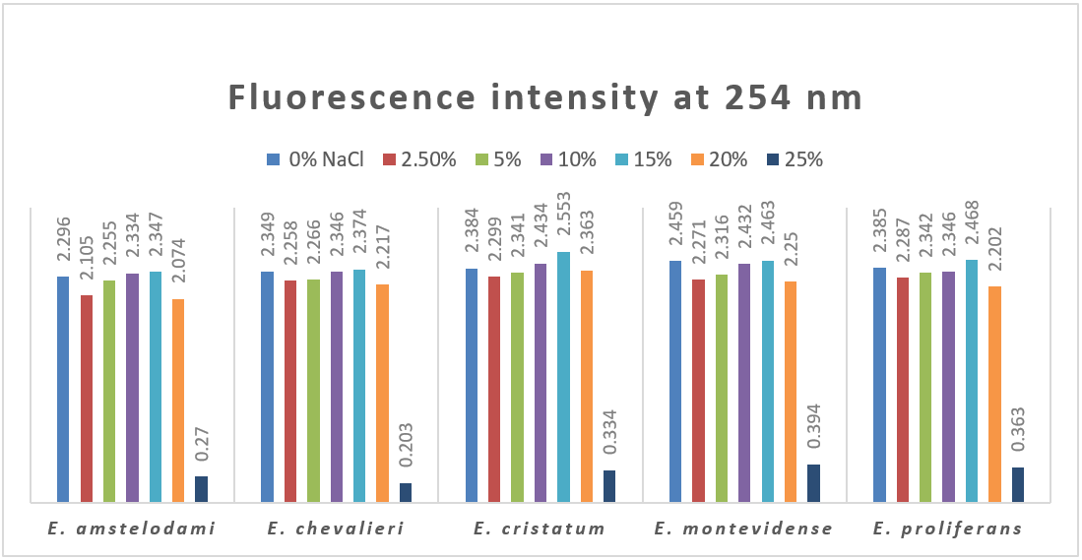
Fig. 5: Fluorescence intensity of Eurotium spp. at 366 nm and 254 nm under different sodium chloride concentrations

5. Organic matter content
The organic matter content of Eurotium species cultures varied significantly with increasing sodium chloride concentrations (Table 5). In general, a gradual enhancement in organic matter was observed as salinity increased up to 15% NaCl, followed by a sharp decline at 20% NaCl and complete inhibition at 25%. E. montevidense exhibited the highest organic matter content (1.890%) at 15% NaCl, followed closely by E. cristatum (1.804%) and E. proliferans (1.732%). Moderate salinity (10–15%) consistently promoted organic matter accumulation in all species, indicating enhanced biosynthesis of cellular and extracellular metabolites under these conditions. In contrast, minimal values were detected at 2.5% NaCl, where organic matter contents ranged only between 0.247–0.588%.

These findings demonstrate that moderate salt stress (particularly 10–15% NaCl) enhances the metabolic activity and organic content of Eurotium cultures, whereas excessive salinity (≥20%) exerts an inhibitory effect. The pattern closely parallels the trends observed for dry weight and fluorescence intensity, suggesting a common physiological response to salinity involving osmoadaptive metabolite synthesis.

Table 5: Effect of sodium chloride concentration on organic matter content (%) of Eurotium species cultures.
 | Control 0% NaCl | 2.5% | 5% | 10% | 15% | 20% | 25%
E. amstelodami | 0.862 | 0.284 | 0.552 | 0.964 | 1.675 | 0.300 | -
E. chevalieri | 0.538 | 0.299 | 0.514 | 0.909 | 1.652 | 0.305 | -
E. cristatum | 0.927 | 0.588 | 0.790 | 1.360 | 1.804 | 0.407 | -
E. montevidense | 0.903 | 0.286 | 0.573 | 1.000 | 1.890 | 0.514 | -
E. proliferans | 0.981 | 0.247 | 0.611 | 1.187 | 1.732 | 0.429 | -

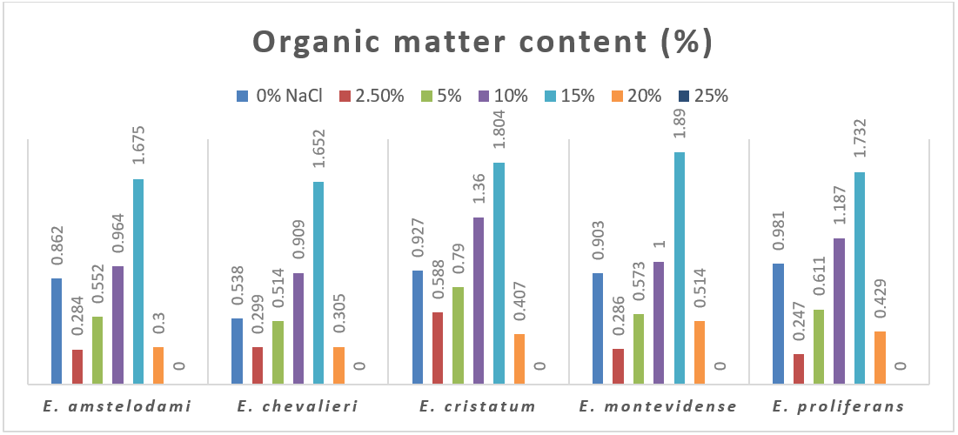
Fig. 6: Effect of sodium chloride concentration on organic matter content (%) of Eurotium spp. cultures

6. Total nitrogen (Kjeldahl method)
The total nitrogen content of Eurotium cultures, determined by the Kjeldahl method, showed marked variation with increasing sodium chloride concentrations (Table 6). In all isolates, nitrogen levels followed a general trend of increasing up to 15% NaCl, followed by a sharp reduction at 20% and complete inhibition of growth and nitrogen accumulation at 25%. Among the examined species, E. amstelodami and E. cristatum exhibited the highest nitrogen content (5.32%) at 15% NaCl, while E. montevidense and E. proliferans reached slightly lower but comparable values (5.04% each). Minimum nitrogen contents were recorded at 20% NaCl, ranging from 1.96% to 2.24% across species.

The observed increase in nitrogen percentage at moderate salinity levels (10–15%) suggests that mild salt stress stimulates protein and enzyme synthesis, reflecting enhanced metabolic activity and adaptation to osmotic stress. Conversely, the decline in nitrogen content at high salinity indicates metabolic inhibition and reduced cellular biosynthesis. These results parallel the patterns of organic matter accumulation and dry weight, confirming that optimal nitrogen metabolism in Eurotium occurs under moderate saline conditions.

Table 6: Total nitrogen content % (Kjeldahl method) of Eurotium species grown at varying sodium chloride concentrations
 | Control 0% NaCl | 2.5% | 5% | 10% | 15% | 20% | 25%
E. amstelodami | 4.20 | 3.08 | 3.64 | 4.76 | 5.32 | 2.24 | -
E. chevalieri | 3.64 | 3.36 | 3.64 | 4.20 | 4.76 | 1.96 | -
E. cristatum | 4.20 | 3.36 | 4.20 | 4.62 | 5.32 | 2.24 | -
E. montevidense | 4.76 | 3.08 | 3.50 | 4.76 | 5.04 | 1.96 | -
E. proliferans | 4.62 | 3.08 | 3.64 | 4.76 | 5.04 | 2.24 | -

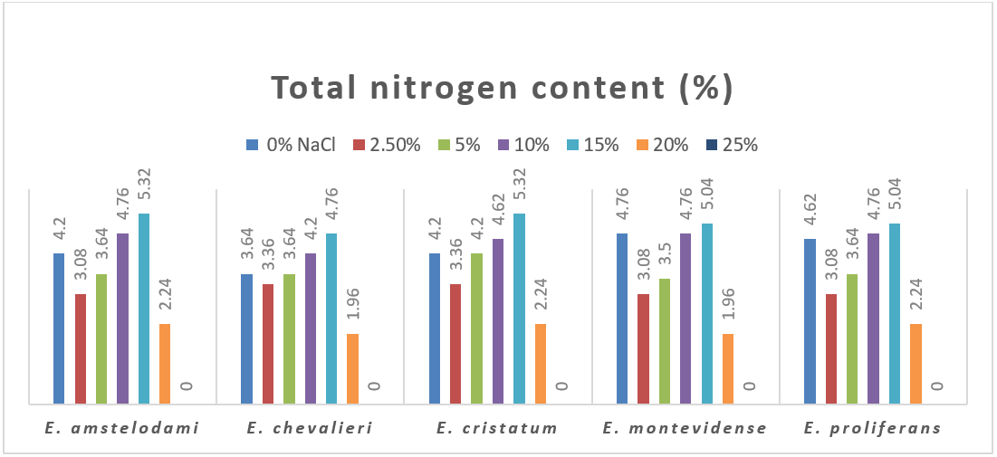
Fig. 7: Effect of sodium chloride concentration on Total nitrogen content (%) of Eurotium spp. cultures

7. Antibacterial activity
The antibacterial activity of Eurotium culture extracts against Bacillus subtilis and Escherichia coli varied according to the sodium chloride concentration used during cultivation (Table 7). The results revealed that moderate salinity enhanced antimicrobial potency, while very high salt levels (≥15% NaCl) completely inhibited activity, coinciding with the cessation of fungal growth. Against B. subtilis, the strongest inhibition was observed for E. proliferans grown under control conditions (0% NaCl), which produced an inhibition zone of 1.5 mm, followed by E. amstelodami (1.4 mm) at 10% NaCl. E. chevalieri, E. cristatum, and E. montevidense exhibited moderate activity (1.0–1.2 mm) at 5–10% NaCl. Similarly, the extracts displayed measurable inhibitory effects against E. coli, with the highest activity also recorded for E. proliferans (1.7 mm) at 0% NaCl and for E. amstelodami (1.5 mm) at 10% NaCl.

No antimicrobial activity was detected at 15% NaCl or higher in any species, indicating that excessive salinity suppresses the biosynthesis of antimicrobial metabolites. The results suggest that Eurotium species produce bioactive compounds most effectively under low to moderate salinity (0–10% NaCl), and that salt-induced metabolic stress beyond this range inhibits secondary metabolite production responsible for antibacterial activity.

Table 7: Antimicrobial activity of Eurotium species cultured under varying sodium chloride concentrations against bacterial species
Eurotium species | Bacillus subtilis |  |  |  |  |  |  | Escherichia coli
Eurotium species | 0% | 2.5% | 5% | 10% | 15% | 20% | 25% | 0% | 2.5% | 5% | 10% | 15% | 20% | 25%
E. amstelodami | 1 | 0.8 | 1 | 1.4 | - | - | - | 1.2 | 1 | 1 | 1.5 | - | - | -
E. chevalieri | 1.2 | 1 | 1 | 1.2 | - | - | - | 1.5 | 1.2 | 1 | 1.2 | - | - | -
E. cristatum | 1.2 | 1.2 | 1 | 1.2 | - | - | - | 1.2 | 1.2 | 1 | 1.2 | - | - | -
E. montevidense | 1.2 | 0.8 | 0.8 | 1 | - | - | - | 1.2 | 1 | 1 | 1.2 | - | - | -
E. proliferans | 1.5 | 1 | 1.2 | 1 | - | - | - | 1.7 | 1 | 1.2 | 1.2 | - | - | -

8. Antifungal activity
The antifungal activity of Eurotium culture extracts against Candida tropicalis AUMC 9138 and Candida albicans AUMC 9158 is summarized in Table 8. The results revealed that all tested Eurotium species exhibited measurable antifungal effects at low to moderate sodium chloride concentrations (0–5%), while no inhibition was detected at higher salt levels (≥10% NaCl). For C. tropicalis, the strongest inhibition was observed for E. amstelodami and E. cristatum, both showing inhibition zones of 1.5 mm at 5% NaCl, followed by E. chevalieri (1.2 mm). Similar trends were observed against C. albicans, where E. amstelodami and E. cristatum again displayed the highest antifungal activity (1.5 mm) at 5% NaCl, and moderate inhibition (1.2–1.35 mm) under control and 2.5% NaCl conditions. E. montevidense and E. proliferans exhibited comparatively lower activity, with inhibition zones not exceeding 1.2 mm.

No antifungal activity was detected at 10% NaCl or above in any species, indicating that high salinity levels inhibit the biosynthesis of antifungal secondary metabolites. Overall, these findings demonstrate that Eurotium species maintain optimal antifungal activity under mild salinity stress (2.5–5% NaCl), while severe osmotic stress completely suppresses bioactive metabolite production.

Table 8: Antimicrobial activity of Eurotium species cultured under varying sodium chloride concentrations against Candida sp
Eurotium species | Candida tropicalis AUMC 9138 |  |  |  |  |  |  | Candida albicans AUMC 9158
Eurotium species | 0% | 2.5% | 5% | 10% | 15% | 20% | 25% | 0% | 2.5% | 5% | 10% | 15% | 20% | 25%
E. amstelodami | 1.2 | 1 | 1.5 | - | - | - | - | 1.2 | 1.35 | 1.5 | - | - | - | -
E. chevalieri | 1.2 | 1 | 1.2 | - | - | - | - | 1.2 | 1.2 | 1.2 | - | - | - | -
E. cristatum | 1.2 | 1 | 1.5 | - | - | - | - | 1.2 | 1.35 | 1.5 | - | - | - | -
E. montevidense | 1 | 1 | 1.2 | - | - | - | - | 1 | 1.1 | 1.2 | - | - | - | -
E. proliferans | 1.2 | 1 | 1 | - | - | - | - | 1.2 | 1 | 0.8 | - | - | - | -

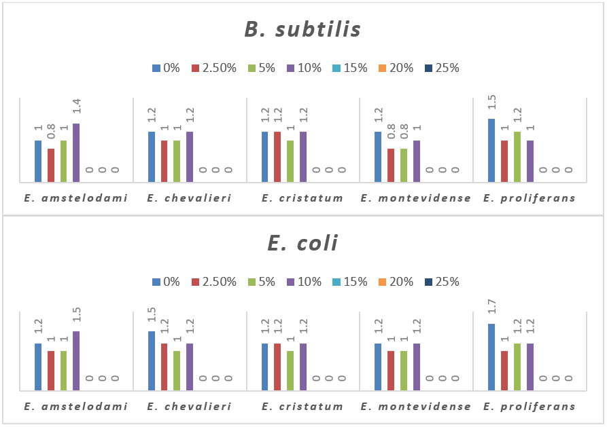
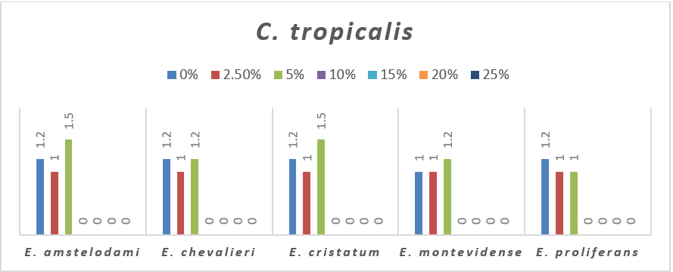
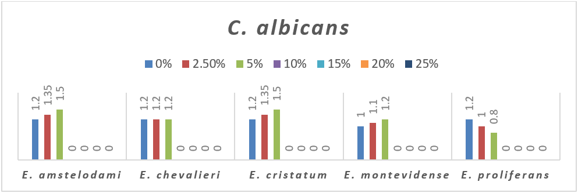
Fig. 8: Antimicrobial activity of Eurotium spp. cultured under varying sodium chloride concentrations

DISCUSSION
Salt tolerance and growth patterns
The five Eurotium isolates in this study showed clear halotolerant behaviour: biomass (dry weight) and organic matter increased with NaCl up to 10–15% and declined sharply at 20% and above (Tables 1 and 5). This pattern (improved growth/metabolism under moderate salinity followed by inhibition at very high salinity) is typical of halotolerant/xerophilic fungi recovered from hypersaline habitats and solar salterns (Gunde-Cimerman & Zalar, 2014). Members of Eurotium and related genera have been repeatedly reported from hypersaline and low-water-activity environments (Gunde-Cimerman et al., 2018), consistent with our observation that several isolates maintain substantial growth at high concentrations of sodium chloride.

Physiological mechanisms of halotolerance
The ability of these Eurotium strains to grow and accumulate biomass at elevated NaCl likely reflects canonical fungal osmoadaptive mechanisms. Fungi commonly respond to hyperosmotic stress by (1) accumulating compatible solutes (polyols such as glycerol, arabitol, mannitol and disaccharides such as trehalose), (2) adjusting membrane lipid composition, and (3) activating osmo-signalling pathways (e.g., HOG/MAPK) that reprogram gene expression for stress protection and metabolism. Several filamentous and halotolerant ascomycetes (including Aspergillus spp. and Aureobasidium) show precisely this pattern, and polyol accumulation has been directly measured in salt-adapted fungi. These mechanisms explain both the maintenance of biomass at moderate salinity and the collapse of growth at very high salinity (20–25%), when osmotic load likely exceeds the capacity for compensation (Rodríguez-Pupo et al., 2021).

Salt effects on secondary metabolism, pigmentation and fluorescence
The observed increased absorbance at 512 nm, higher fluorescence (particularly at 366 nm), and higher organic/nitrogen content in cultures grown at 10–15% NaCl (Tables 3-6). This coupling of increased secondary-metabolite signals with moderate salt stress is well documented: osmotic or saline stress can redirect carbon flux from growth to secondary metabolite biosynthesis, alter metabolite profiles, and induce novel or enhanced pigment and halogenated compound production in fungi. Studies have shown that salinity can both qualitatively change the metabolite suite and increase titers of particular compounds (including pigments, polyketides and some halogenated molecules) in halotolerant strains. The stronger response at 366 nm in our dataset may reflect accumulation of aromatic polyketides, flavin-like compounds, or other chromophores whose excitation/emission fall in the UV-visible band (Wang et al., 2011).

Nitrogen content and organic matter are linked to metabolic regulation
Total nitrogen and organic matter peaked at 10–15% NaCl (Table 6 & 5), mirroring biomass and secondary metabolite indicators. Increased nitrogen percentage under moderate saline stress likely reflects a relative enrichment of nitrogenous cellular components (enzymes, stress proteins, nitrogen-rich secondary metabolites) and/or concentration effects as water activity decreases. This observation supports the idea that mild osmotic stress stimulates specific biosynthetic pathways (including enzymes and nitrogenous secondary metabolites), whereas severe stress (≥20%) impairs protein synthesis and biomass accrual. Similar patterns (increased protein/enzymatic investment in stress response at tolerable salinities and collapse under extreme salinity) have been reported in other salt-tolerant fungi (Rodríguez-Pupo et al., 2021).

Antimicrobial and antifungal activities under salinity regimes
Antibacterial and antifungal activities were strongest at low to moderate salinity (0–15% & 0–10% NaCl, respectively) and absent at ≥15% where growth ceased (Tables 7–8). Two explanations are consistent with the literature: (1) the biosynthesis of bioactive secondary metabolites is upregulated at moderate osmotic stress (giving larger inhibition zones), and (2) at higher salinity, the fungus either does not grow sufficiently to produce metabolites or shifts metabolism away from secondary metabolite pathways. Multiple studies show that salinity can both increase and reprogram natural-product expression (sometimes yielding novel bioactive compounds under saline culture), but responses are strain- and compound-specific. Thus, the peak of bioactivity at moderate salinity agrees with previous findings that controlled osmotic stress can be used as a tool to enhance or diversify fungal secondary chemistry (Wang et al., 2011; Yovchevska et al., 2025a).

An adaptive stress response
The parallel peaks in dry weight, absorbance, fluorescence, organic matter, and nitrogen at 10–15% NaCl indicate that this salinity range constitutes a physiological optimum for these Eurotium isolates under the tested conditions. At those salinities, the organisms appear to mount an effective osmoadaptive program: retaining growth, accumulating compatible solutes and stress proteins, and channeling metabolic resources into chromophoric and bioactive secondary metabolites. At 20% and above, the failure to sustain growth correlates with loss of pigment/fluorescence signals and absence of antimicrobial activity, consistent with osmotic overload and metabolic shutdown. This pattern (an intermediate salinity optimum with collapse at extreme salinity) is characteristic of halotolerant (as opposed to strictly halophilic) fungi (Butinar et al., 2005; Gunde-Cimerman et al., 2009)

Broader implications and applications
The findings reinforce that Eurotium spp. Are promising sources of salt-stable enzymes and halotolerant secondary metabolites with potential biotechnological uses (bioremediation in saline waste, salt-tolerant fermentation processes, and discovery of novel halogenated bioactives). Furthermore, the observation that controlled salinity can boost metabolite accumulation suggests a practical cultivation strategy: tuning NaCl to the species-specific optimum (~10–15%) to maximize yields of desired pigments or antimicrobial compounds. Recent reviews highlight the biotechnological potential of salt-tolerant and xerophilic fungi for such applications (Pócsi et al., 2024).

Limitations and recommendations for future work
Profile secondary metabolites.
Use LC-MS/MS and NMR to identify the pigments and antimicrobial compounds that increase at 10–15% NaCl; salinity can change both quantity and identity of metabolites and occasionally yields novel halogenated products (Wang et al., 2011).

Include osmotic controls.
Parallel experiments using non-ionic osmolytes (e.g., glycerol) help disentangle ionic (Na⁺/Cl⁻) effects from general low-water-activity responses, as osmotic and saline treatments can produce different metabolite responses (Overy et al., 2017)

The dataset demonstrates that the examined Eurotium isolates are halotolerant: they show optimal growth and elevated production of pigments, nitrogenous material, and antimicrobial compounds at moderate salinities (≈10–15% NaCl), and a collapse of growth and metabolite production at ≥20% NaCl. These results are consistent with the ecology and physiology reported for halotolerant/xerophilic fungi and indicate both mechanistic and applied avenues for further research (osmolyte analysis, metabolite profiling, and optimization of saline cultivation for bioproduct yield). The genus Eurotium – members of the indigenous fungal community in hypersaline waters of salterns (Zajc et al., 2014)

CONCLUSION
The five Eurotium species examined in this study demonstrated clear halotolerant capabilities, with optimal growth, metabolite accumulation, and antimicrobial activity occurring under moderate salinity (10–15% NaCl). High salt concentrations (≥20%) severely inhibited growth, secondary metabolite production, and bioactivity, highlighting the upper physiological limits of these fungi. The parallel peaks observed in biomass, organic matter, nitrogen content, fluorescence, and antimicrobial activity indicate that moderate osmotic stress enhances both primary and secondary metabolism. These findings underscore the ecological adaptability of Eurotium species to saline environments and their potential as sources of halotolerant enzymes, pigments, and bioactive compounds for biotechnological applications.

REFERENCES
- Abdel-Hafez, S. I., Maubasher, A. H., & Abdel-Fattah, H. M. (1978). Cellulose-decomposing fungi of salt marshes in Egypt. Folia microbiologica, 23(1), 37-44.‏
- Abdel-Hafez, S. I., Mohawed, S. M., & El-Said, A. H. (1989). Seasonal fluctuations of soil fungi of Wadi Qena at eastern desert of Egypt. Acta Mycologica, 25(1), 113-125.‏
- Ayangbenro, A. S., & Babalola, O. O. (2017). A new strategy for heavy metal polluted environments: a review of microbial biosorbents. International journal of environmental research and public health, 14(1), 94.‏
- Bowers, K. J., Mesbah, N. M., & Wiegel, J. (2009). Biodiversity of poly-extremophilic Bacteria: does combining the extremes of high salt, alkaline pH and elevated temperature approach a physico-chemical boundary for life? Saline systems, 5(1), 9.‏
- Bremer, E., & Krämer, R. (2019). Responses of microorganisms to osmotic stress. Annual review of Microbiology, 73(1), 313-334.‏
- Buchalo, A. S., Nevo, E., Wasser, S. P., Oren, A., & Molitoris, H. P. (1998). Fungal life in the extremely hypersaline water of the Dead Sea: first records. Proceedings of the Royal Society of London. Series B: Biological Sciences, 265(1404), 1461-1465.‏
- Butinar, L., Zalar, P., Frisvad, J. C., & Gunde-Cimerman, N. (2005). The genus Eurotium–members of indigenous fungal community in hypersaline waters of salterns. FEMS Microbiology Ecology, 51(2), 155-166.‏
- Casamayor, E. O., Massana, R., Benlloch, S., Øvreås, L., Díez, B., Goddard, V. J., ... & Pedrós‐Alió, C. (2002). Changes in archaeal, bacterial and eukaryal assemblages along a salinity gradient by comparison of genetic fingerprinting methods in a multipond solar saltern. Environmental Microbiology, 4(6), 338-348.‏
- Dutta, B., & Bandopadhyay, R. (2022). Biotechnological potentials of halophilic microorganisms and their impact on mankind. Beni-Suef University Journal of Basic and Applied Sciences, 11(1), 75.
- El-Maghraby, O. M. O, Youssef, M. S, Marwa AbdeL-Kareem, M, Randa Fathy, A (2025). Biodiversity of salt-adapted filamentous fungi of Red Sea coast in Upper Egypt. Saudi J. Med. Pharm. Sci., 11(3), 139-148.
- El-Maghraby, O. M. O, Youssef, M. S, Marwa AbdeL-Kareem, M, Randa Fathy, A (2022). Physicochemical analyses and mycoflora of desert soils in Upper Egypt. Saudi J Med Pharm Sci, 8(11), 694-705.
- Gostinčar, C., & Gunde-Cimerman, N. (2024). Black yeasts in hypersaline conditions. Applied microbiology and biotechnology, 108(1), 252.‏
- Grishkan, I., Nevo, E., & Wasser, S. P. (2003). Soil micromycete diversity in the hypersaline Dead Sea coastal area, Israel. Mycological Progress, 2(1), 19-28.‏
- Gunde-Cimerman, N., & Zalar, P. (2014). Extremely halotolerant and halophilic fungi inhabit brine in solar salterns around the globe. Food Technology and Biotechnology, 52(2), 170-179.‏
- Gunde-Cimerman, N., Plemenitaš, A., & Oren, A. (2018). Strategies of adaptation of microorganisms of the three domains of life to high salt concentrations. FEMS microbiology reviews, 42(3), 353-375.‏
- Gunde-Cimerman, N., Ramos, J., & Plemenitaš, A. (2009). Halotolerant and halophilic fungi. Mycological research, 113(11), 1231-1241.‏
- Gunde-Cimerman, N., Zalar, P., de Hoog, S., & Plemenitaš, A. (2000). Hypersaline waters in salterns–natural ecological niches for halophilic black yeasts. FEMS microbiology Ecology, 32(3), 235-240.‏
- Hmad, I. B., & Gargouri, A. (2024). Halophilic filamentous fungi and their enzymes: potential biotechnological applications. Journal of Biotechnology, 381, 11-18.
- Kis-Papo, T., Grishkan, I., Oren, A., Wasser, S. P., & Nevo, E. (2001). Spatiotemporal diversity of filamentous fungi in the hypersaline Dead Sea. Mycological Research, 105(6), 749-756.‏
- Le Borgne, S., Paniagua, D., & Vazquez-Duhalt, R. (2008). Biodegradation of organic pollutants by halophilic bacteria and archaea. Journal of molecular microbiology and biotechnology, 15(2-3), 74-92.‏
- Nout, M. J. R., Samson, R. A., Hoekstra, E. S., Frisvad, J. C., & Filtenborg, O. (1995). Introduction to food‐borne fungi.‏
- Onofri, S., de Vera, J. P., Zucconi, L., Selbmann, L., Scalzi, G., Venkateswaran, K. J. & Horneck, G. (2015). Survival of Antarctic cryptoendolithic fungi in simulated Martian conditions on board the International Space Station. Astrobiology, 15(12), 1052-1059.‏
- Oren, A. (1999). Bioenergetic aspects of halophilism. Microbiology and molecular biology reviews, 63(2), 334-348.‏
- Oren, A. (2002). Halophilic microorganisms and their environments. Dordrecht: Springer Netherlands.‏ Book (Chapter: 5) P: 419-440
- Oren, A. (2010). Industrial and environmental applications of halophilic microorganisms. Environmental technology, 31(8-9), 825-834.‏
- Overy, D., Correa, H., Roullier, C., Chi, W. C., Pang, K. L., Rateb, M., ... & Kerr, R. (2017). Does osmotic stress affect natural product expression in fungi?. Marine drugs, 15(8), 254.‏
- Pacelli, C., Selbmann, L., Zucconi, L., Coleine, C., de Vera, J. P., Rabbow, E. & Onofri, S. (2019). Responses of the black fungus Cryomyces antarcticus to simulated mars and space conditions on rock analogs. Astrobiology, 19(2), 209-220.‏
- Parray, J. A., Mahmoud, A. H. A. E., & Sayyed, R. (Eds.). (2021). Soil Bioremediation: An Approach Towards Sustainable Technology. John Wiley & Sons.‏
- Pedrós-Alió, C., Calderón-Paz, J. I., MacLean, M. H., Medina, G., Marrasé, C., Gasol, J. M., & Guixa-Boixereu, N. (2000). The microbial food web along salinity gradients. FEMS Microbiology Ecology, 32(2), 143-155.‏
- Pitt, J. I., & Hocking, A. D. (2009). Fungi and food spoilage (Vol. 519, p. 388). New York: Springer.‏
- Plemenitaš, A., Konte, T., Gostinčar, C., & Cimerman, N. G. (2016). Transport systems in halophilic fungi. Yeast membrane transport, 307-325.‏
- Pócsi, I., Dijksterhuis, J., Houbraken, J., & de Vries, R. P. (2024). Biotechnological potential of salt tolerant and xerophilic species of Aspergillus. Applied Microbiology and Biotechnology, 108(1), 521.‏
- Ramos-Cormenzana, A. (1991). Halophilic organisms and the environment. In General and applied aspects of halophilic microorganisms (pp. 15-24). Boston, MA: Springer US.‏
- Rodríguez-Pupo, E. C., Pérez-Llano, Y., Tinoco-Valencia, J. R., Sánchez, N. S., Padilla-Garfias, F., Calahorra, M., ... & Sánchez-Carbente, M. D. R. (2021). Osmolyte signatures for the protection of Aspergillus sydowii cells under halophilic conditions and osmotic shock. Journal of Fungi, 7(6), 414.‏
- Samson, R. A. (2002). Introduction to food and airborne fungi. American Society Microbiology.‏
- Seckbach, J., & Rampelotto, P. H. (2015). Polyextremophiles. Microbial Evolution under Extreme Conditions; Bakermans, C., Ed.; De Gruyter Publishers: Berlin, Germany, 153-170.‏
- Su, C. (2014). A review on heavy metal contamination in the soil worldwide: Situation, impact and remediation techniques. Environmental Skeptics and Critics, 3(2), 24.‏
- Ventosa, A., Nieto, J. J., & Oren, A. (1998). Biology of moderately halophilic aerobic bacteria. Microbiology and molecular biology reviews, 62(2), 504-544.‏
- Wang, Y., Lu, Z., Sun, K., & Zhu, W. (2011). Effects of High Salt Stress on Secondary Metabolite Production in the Marine-Derived Fungus Spicaria elegans. Marine Drugs, 9(4), 535-542.
- Yovchevska, L., Gocheva, Y., Stoyancheva, G., Miteva-Staleva, J., Dishliyska, V., Abrashev, R., Stamenova, T., Angelova, M., & Krumova, E. (2025b). Halophilic Fungi-Features and Potential Applications. Microorganisms, 13(1), 175.
- Yovchevska, L., Miteva-Staleva, J., Dishliyska, V., Stoyancheva, G., Gocheva, Y., Abrashev, R., Spasova, B., Angelova, M., & Krumova, E. (2025a). Response to Salt Stress of the Halotolerant Filamentous Fungus Penicillium chrysogenum P13. Molecules, 30(6), 1196.
- Zajc, J., Džeroski, S., Kocev, D., Oren, A., Sonjak, S., Tkavc, R., & Gunde-Cimerman, N. (2014). Chaophilic or chaotolerant fungi: a new category of extremophiles? Frontiers in microbiology, 5, 708.
‏

